Software Requirements Specification (SRS)

hotrotuhocoto.vercel.app – AutoEdu LMS
12/2025
Prepared by Nguyen Ngoc Tuan

Table of contents
1. Introduction 4
1.1 Purpose 4
1.2 Scope 4
1.3 Definitions and Abbreviations 4
1.4 References 5
2. Overall Description 5
2.1 Product Perspective 5
2.2 Product Functions (High-Level) 5
2.3 User Classes 5
2.4 Assumptions and Dependencies 5
3. Specific Requirements 6
3.1 External Interface Requirements 6
3.1.1 User Interface 6
3.1.2 Software Interface 6
3.1.3 Communications Interface 6
3.2 Functional Requirements 6
3.2.1 Authentication and Access Control 6
3.2.2 Student Requirements 6
3.2.3 Teacher Requirements 7
3.2.4 Admin Requirements 8
3.2.5 Validation and Control 8
3.3 Non-Functional Requirements 8
3.3.1 Security 8
3.3.2 Performance 8
3.3.3 Reliability 9
3.3.4 Usability 9
3.4 Data Requirements (ERD-aligned) 9
3.5 Business Rules 10
4. Role-Based Access Matrix (CRUD + Scope) 10
5. Traceability Matrix (Use Cases to Requirements) 11
6. Acceptance Criteria (System-Level) 11
7. Out of Scope (Current Release) 12
8. Appendix A: Priority (MoSCoW) 12
9. Appendix B: Key Risks 12
10. Appendix C: Artifacts 12
10.1. Usecase Diagram. 12
10.2. BPMN Diagram. 16
10.3. ERD. 17

1. Introduction

1.1 Purpose
This document defines the business and system requirements for AutoEdu LMS. It is intended to:
- Align stakeholders (Business, BA, Development, QA).
- Provide a baseline for design, implementation, testing, and acceptance.
- Ensure traceability from Use Cases, BPMN, and ERD to implementation requirements.

1.2 Scope
AutoEdu LMS is a role-based learning management platform for three user groups:
- Student
- Teacher
- Admin

In scope:
- Authentication and role-based access
- Subject and class management
- Lecture and learning content management
- Assignment and exam lifecycle management
- Submission and grading
- Bulk import and enrollment operations
- Dashboards and role-based reporting

1.3 Definitions and Abbreviations
- LMS: Learning Management System
- SRS: Software Requirements Specification
- FR: Functional Requirement
- NFR: Non-Functional Requirement
- BR: Business Rule
- UAT: User Acceptance Testing
- CRUD: Create, Read, Update, Delete
- Attempt: A single try by a student to complete an assignment/exam
- Submission: Student response package for an assignment/exam

1.4 References
- ERD (project artifact)
- Use Case Diagrams (3 diagrams, project artifacts)
- BPMN Diagram (project artifact)

2. Overall Description

2.1 Product Perspective
AutoEdu LMS consists of three portals sharing a centralized data platform:
- Student Portal
- Teacher Portal
- Admin Portal

2.2 Product Functions (High-Level)
- Authenticate users and route by role
- Manage subjects, classes, and learning materials
- Create and manage assignments/exams with attempt and timing rules
- Support submissions, auto-scoring (objective), and manual grading (subjective)
- Support account administration, bulk import, and bulk enrollment

2.3 User Classes
- Student: Learns course content, submits work, tracks results
- Teacher: Manages instruction, assessments, and grading
- Admin: Manages accounts and academic onboarding operations

2.4 Assumptions and Dependencies
- Subjects and classes are configured before student participation
- Each account has one active role at login
- Import files follow approved templates
- Access control is enforced consistently across application and data layers

3. Specific Requirements

3.1 External Interface Requirements

3.1.1 User Interface
- Role-specific navigation and dashboard
- List views support filter/search/sort
- Forms provide validation and clear feedback

3.1.2 Software Interface
- Authentication provider
- Relational data store
- File storage service for lecture materials
- Internal APIs for import and enrollment

3.1.3 Communications Interface
- Secure HTTP(S) for all user interactions
- API request/response with explicit success/error status

3.2 Functional Requirements

3.2.1 Authentication and Access Control
FR-001: The system shall allow Student and Teacher users to sign in with valid credentials.
FR-002: The system shall allow Admin users to sign in via the admin portal.
FR-003: The system shall route users to the correct role-based dashboard after successful sign-in.
FR-004: The system shall allow authenticated users to change their own password.
FR-005: The system shall deny access to features outside the user's role scope.

3.2.2 Student Requirements
FR-101: The system shall allow Students to view enrolled classes.
FR-102: The system shall allow Students to join a class using a valid class code.
FR-103: The system shall allow Students to view and download lecture resources for enrolled classes.
FR-104: The system shall allow Students to view assignment lists with due dates and status.
FR-105: The system shall allow Students to start assignment attempts when eligible.
FR-106: The system shall store assignment submissions with status and timestamp.
FR-107: The system shall allow Students to view submission history and results per policy.
FR-108: The system shall allow Students to view available exams and status.
FR-109: The system shall allow Students to start exam attempts only within valid time windows.
FR-110: The system shall support manual exam submission and automatic submission on timeout.
FR-111: The system shall auto-grade objective-only assessments and mark subjective submissions as pending grading.

3.2.3 Teacher Requirements
FR-201: The system shall allow Teachers to create, update, view, and delete classes in their scope.
FR-202: The system shall allow Teachers to create and update subjects.
FR-203: The system shall allow Teachers to create, update, view, and delete lectures and lecture files.
FR-204: The system shall allow Teachers to create, update, view, and delete assignments.
FR-205: The system shall allow Teachers to manage assignment question banks.
FR-206: The system shall allow Teachers to create, update, view, and delete exams.
FR-207: The system shall allow Teachers to manage exam question banks.
FR-208: The system shall allow Teachers to view submissions by class/assessment.
FR-209: The system shall allow Teachers to grade assignment submissions with score and feedback.
FR-210: The system shall allow Teachers to grade exam submissions with score and feedback.
FR-211: The system shall provide teaching dashboards and summary statistics.

3.2.4 Admin Requirements
FR-301: The system shall allow Admins to create, read, update, and delete user accounts.
FR-302: The system shall allow Admins to reset user passwords.
FR-303: The system shall allow Admins to import users from file templates.
FR-304: The system shall allow Admins to bulk enroll students into classes.
FR-305: The system shall return processing summaries for bulk operations (success/failure counts and details).

3.2.5 Validation and Control
FR-401: The system shall prevent new attempts when maximum attempts are reached.
FR-402: The system shall prevent exam starts outside the configured exam window.
FR-403: The system shall prevent duplicate enrollment records for the same student-class pair.
FR-404: The system shall store key lifecycle timestamps (start, submit, grade).
FR-405: The system shall display detailed answer review only when enabled by teacher policy.

3.3 Non-Functional Requirements

3.3.1 Security
NFR-001: Role-based access control shall be enforced for all protected functions.
NFR-002: All credential and sensitive data flows shall use secure transport.
NFR-003: The system shall maintain operational logs for auditable events.

3.3.2 Performance
NFR-101: Core user actions shall return responses within acceptable institutional usability thresholds.
NFR-102: Submission, grading, and bulk processing actions shall return deterministic success/error outcomes.

3.3.3 Reliability
NFR-201: A confirmed submission shall not be lost.
NFR-202: Bulk operations shall support partial success with row-level error reporting.

3.3.4 Usability
NFR-301: User interface language and flow shall be clear and role-appropriate.
NFR-302: Error messages shall be actionable and understandable to non-technical users.

3.4 Data Requirements (ERD-aligned)
Core entities:
- Profiles
- Subjects
- Classes
- Enrollments
- Lectures
- LectureFiles
- Assignments
- AssignmentQuestions
- AssignmentSubmissions
- Exams
- ExamQuestions
- ExamSubmissions
- ActivityLogs

Data integrity rules:
DR-001: Business identifiers (e.g., student ID, class code) shall remain unique where defined.
DR-002: Enrollment records shall reference valid student and class records.
DR-003: Submission records shall reference valid assessment and student records.
DR-004: Referential integrity shall be preserved for create/update/delete operations.
DR-005: Scores shall be constrained to valid scoring ranges for each assessment.

3.5 Business Rules
BR-01: Each assessment has a maximum number of allowed attempts.
BR-02: Exams are accessible only within configured start and end times.
BR-03: Active exam attempts are auto-submitted when time expires.
BR-04: Subjective responses require manual teacher grading.
BR-05: Duplicate class enrollment for a student is not allowed.
BR-06: Detailed answer review depends on teacher-configured visibility policy.
BR-07: Grading actions must record grading timestamp and feedback.

4. Role-Based Access Matrix (CRUD + Scope)
Note: C=Create, R=Read, U=Update, D=Delete

- Accounts
Student: R (own)
Teacher: R (own)
Admin: C/R/U/D (all managed users)

- Subjects
Student: R
Teacher: C/R/U (teaching scope)
Admin: R

- Classes
Student: R (enrolled only)
Teacher: C/R/U/D (own classes)
Admin: R (oversight)

- Enrollments
Student: C/R (self-join and own enrollments)
Teacher: C/R/U/D (own class scope)
Admin: C/R/U/D (global and bulk)

- Lectures
Student: R (enrolled classes)
Teacher: C/R/U/D (own classes)
Admin: R

- Assignments
Student: R + C/U (own attempts/submissions)
Teacher: C/R/U/D + grading (own classes)
Admin: R

- Exams
Student: R + C/U (own attempts/submissions)
Teacher: C/R/U/D + grading (own classes)
Admin: R

5. Traceability Matrix (Use Cases to Requirements)
UC-01 Complete Online Examination -> FR-108, FR-109, FR-110, FR-111, FR-401, FR-402, FR-404, BR-02, BR-03
UC-02 Bulk User Provisioning and Enrollment -> FR-301, FR-303, FR-304, FR-305, FR-403, BR-05
Join Class by Code -> FR-102, FR-403
Grade Assignment Submission -> FR-208, FR-209, FR-404, BR-07
Grade Exam Submission -> FR-208, FR-210, FR-404, BR-07

6. Acceptance Criteria (System-Level)
AC-001: All core role-based flows (Student, Teacher, Admin) pass UAT as defined by approved use cases.
AC-002: No open Critical or High defects remain for login, submission, grading, import, and enrollment.
AC-003: Assessment results and submission statuses are consistent between UI and persisted data.
AC-004: Role-based access boundaries are validated and enforced.
AC-005: Business stakeholders provide formal acceptance sign-off.

7. Out of Scope (Current Release)
- Payment processing
- Live video classroom module
- Native mobile application
- AI proctoring and advanced anti-cheating controls
- External public API integrations

8. Appendix A: Priority (MoSCoW)
Must: FR-001..005, FR-101..111, FR-201..211, FR-301..305, FR-401..405
Should: Extended analytical reporting
Could: Advanced longitudinal learning analytics
Won't (this release): Out-of-scope items listed above

9. Appendix B: Key Risks
R-01: Import data quality issues during semester onboarding
R-02: Access control misconfiguration risk
R-03: Peak load risk during concurrent exam sessions

10. Appendix C: Artifacts

10.1. Usecase Diagram.
- Actor: Student

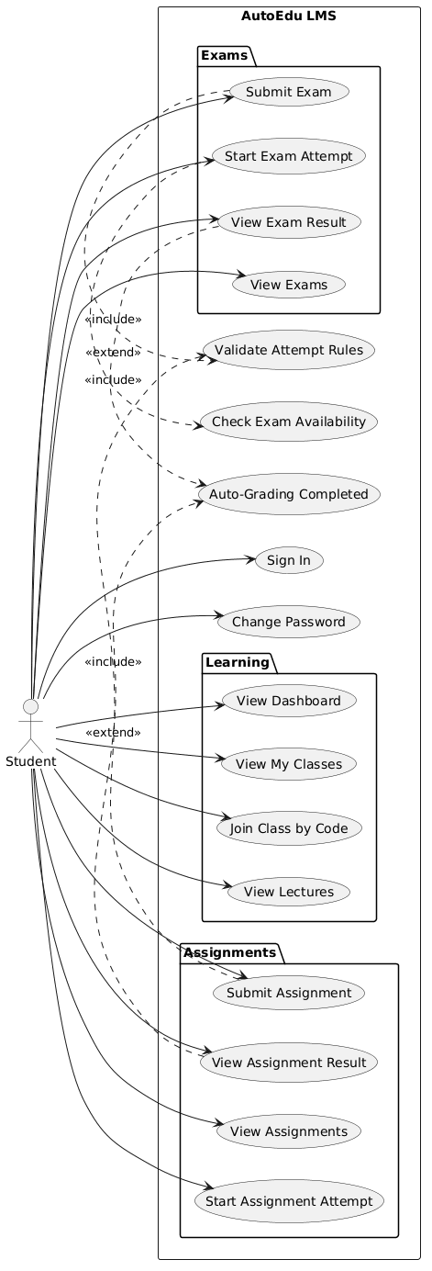

- Actor: Teacher
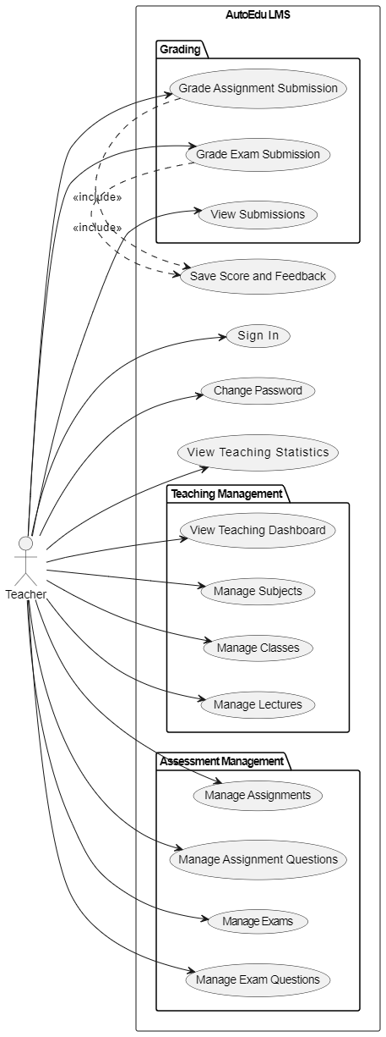
- Actor: Admin

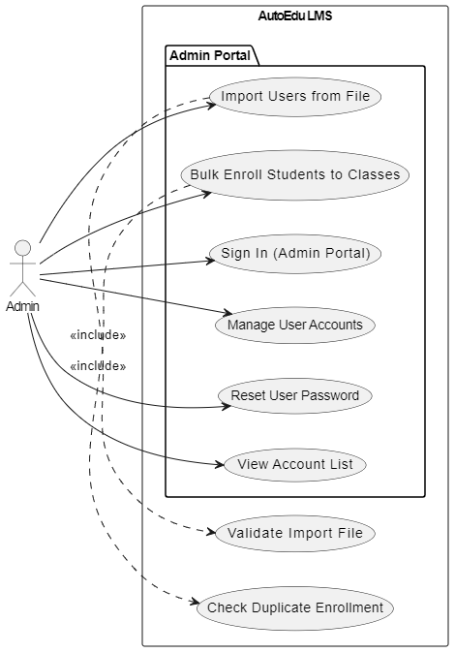

10.2. BPMN Diagram.
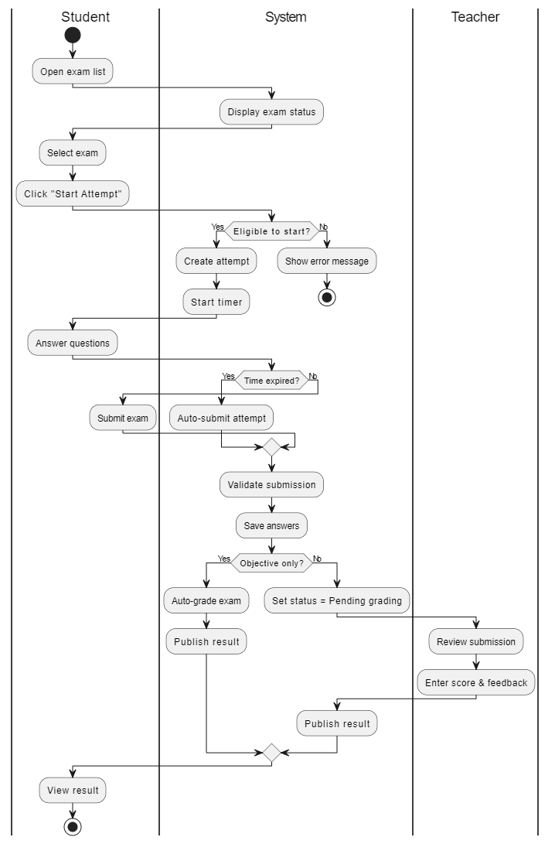

10.3. ERD.

